**A Compact 24 GHz FMCW and Doppler Radar System**

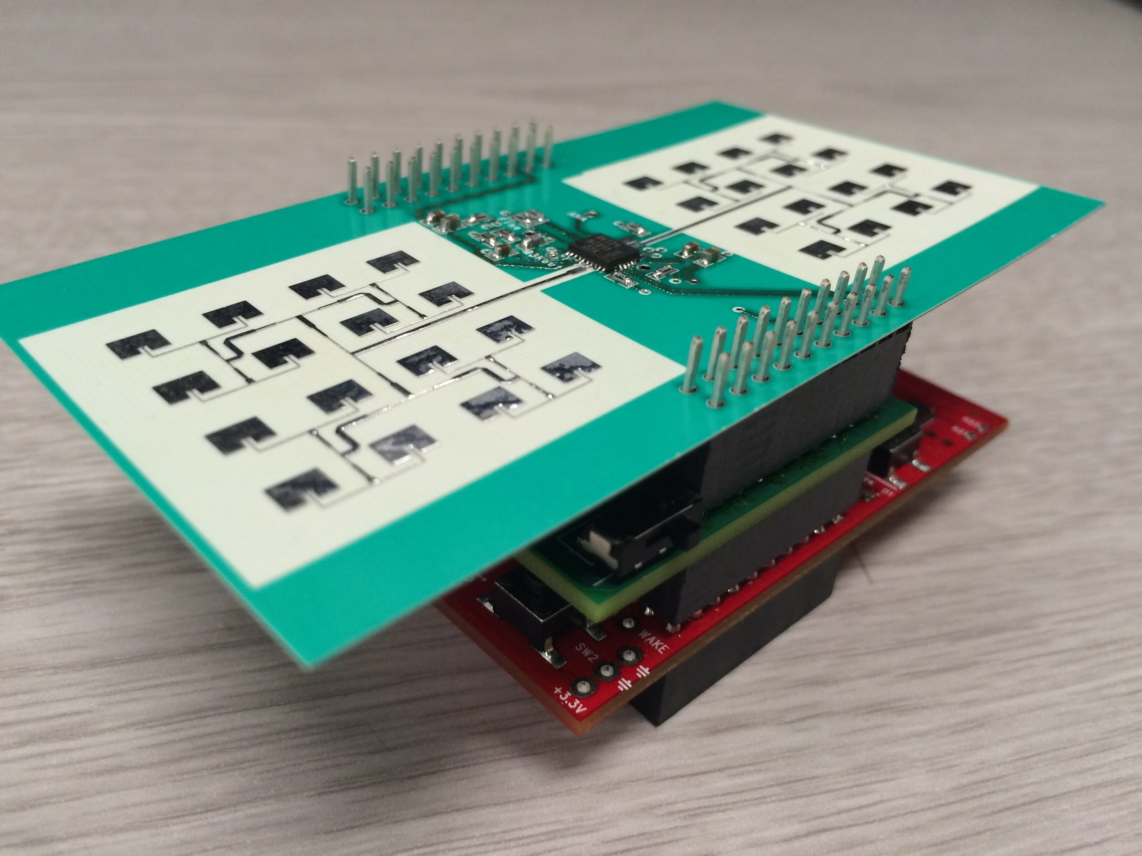

**University of California, Davis**

**EEC 134AB Senior Design**

**Team Stefan and Joe**

**5/21/2015**

**Abstract**

For the Fall and Spring quarters of the 2014-2015 school year, we worked on designing, building and testing a 24GHz Doppler/FMCW radar system. The design criteria were: i) Lightweight ii) Accurate iii) Efficiency. To meet these design criteria our team implemented a patch array antenna to achieve high directivity, used the lightweight material Rogers RO4350b with 1oz copper for the RF board, and used the Infineon BGT24MTR11 24GHz MMIC as the heart of the radar system. The final system consists of three layers: the baseband, the microprocessor and the RF board. The baseband regulates power, amplifies the received demodulated radar signal, adjusts the coarse tune of the Infineon BGT24MTR11 via a digital potentiometer, and houses the digital to analog converter for use in FMCW mode. The Texas Instruments TIVA was chosen to produce the data for a triangle wave for use in FMCW mode, and possibly for signal processing of the demodulated signal. The RF board was designed to be as power efficient and low noise as possible. We used ANSYS HFSS to simulate the patch array antenna, Cadence Allegro to design the PCBs, and Bay Area Circuits for fabrication. Once the completed circuit boards were received and populated they were tested and the long process of debugging began. Debugging our system was a large part of the project and it will be reviewed extensively on the following pages.

**Design**

Our radar design is composed of two custom PCBs and one Tiva Launchpad. Standard 2X10 headers found on the Tiva datasheet were used to connect all three boards. The top layer is an RF board with Rogers RO3450B. The middle layer is a baseband board with the standard dielectric FR4. The bottom board is an evaluation board for the M4F based microprocessor. The function of each board and its schematic is shown below.

**RF Board and Antennas**

The RF board has relatively few components: the Infineon BGT24, terminating resistors, bypass capacitors, and two 4X4 patch array antennas. This board was intentionally kept simple to prevent noise from coupling to the antennas. In the first stages of the design we intended to separate the Infineon MMIC and the antenna due to noise considerations. In meeting with Professor Leo, he strongly recommended instantiating the antenna on the same board as the Infineon and connecting them with a 50 ohm microstrip line. This choice was made due to the high cost of SMA connectors that could handle a 24GHz frequency with low reflection. The two patch array antennas needed to be impedance matched to the **RF Schematic** Tx and Rx pins of the Infineon. Fortunately, Infineon provided the geometry for both the Tx and Rx impedance transformers along with a detailed schematic of the output and input resistances of the Tx and Rx pins. A quick calculation check with a microwave impedance calculator showed that the dimensions were correct. It was recommended by Professor Leo that we terminate the differential transmitted signal of the Infineon through a 50 ohm resistor. The output of the local oscillator for the Infineon was also terminated to a 50 ohm resistor. 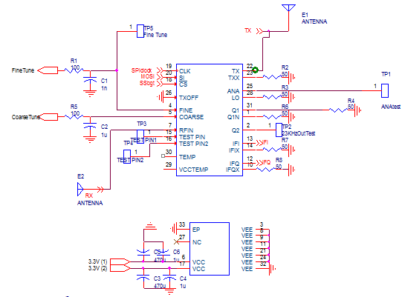

The next step in designing the RF board was the schematic and PCB layout. In taking noise into account, it was imperative to isolate both the Tx and Rx microstrip lines from the SPI lines and the power lines. **RF PCB** In order to achieve a high level of isolation we decided that we would not cross the microstrip line of Tx and Rx on the bottom layer of the RF board. This made coordination of the 2x10 pin headers connecting the baseband and the RF board imperative. Our team met together and decided what pins were best suited to pass both SPI and Power through in order to achieve a low noise system. 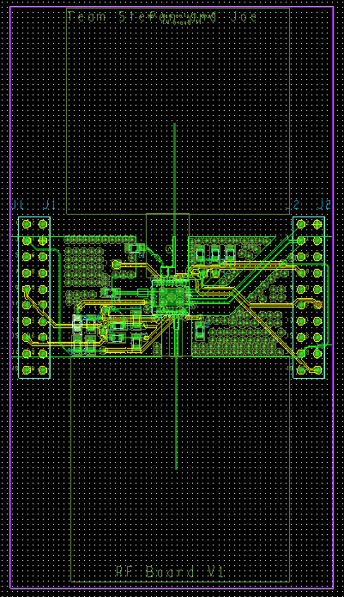

To the upper right is a schematic capture of the RF board. Infineon made the design much easier than anticipated by providing both a schematic symbol and a PCB footprint available for download directly from their website.There were relatively few components on the RF board, but much more care needed to be taken pertaining to the impedance matching networks. To the right, one can see a picture of the RF PCB in Cadence Allegro. The antenna’s are not shown, but are usually at the top and the bottom of the traces running vertically. The toughest issues in dealing with the design of the RF PCB were designing the impedance transformers in Cadence Allegro, and making sure that noise isolation was well thought out.

At first, the design of the RF PCB was done in Eagle CAD because Infineon offered the MMIC footprint. Soon after we started designing the PCB in Eagle, we realized that we could import designs directly from Ansys HFSS into Cadence Allegro. After deciding to place the antenna directly on the board, Cadence Allegro became the obvious choice for our PCB CAD software. The learning curve was steep for this software, but well worth it in the end. 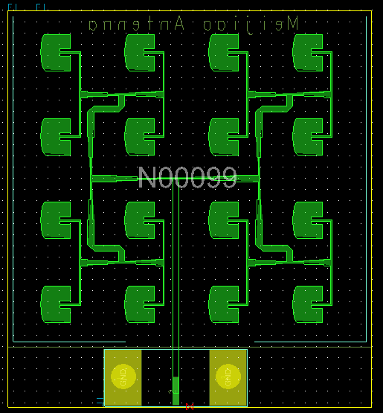

There were three antennas taken into consideration for our design. Hao generously  **Antenna Test Board**  gave us a design for a 25GHz 4x4 patch array antenna. We took this design file and with the assistance of Jay, built an antenna test board. Unfortunately, the router used to make this board was not quite precise enough, and the S11 results returned with a much lower frequency (23 GHz) and higher return loss than anticipated. Hao took this into consideration and designed a 26GHz antenna to address the frequency shift associated with the fabrication. Meijao also designed a 24GHz patch array antenna with the intention of achieving a higher bandwidth by rounding the edges. Because we had so many different antenna’s to choose from, Professor Leo recommended designing an antenna test board so that we could test the return loss of the professionally fabricated antennas. The test board for Meijao’s 25 GHz design can be seen to the right. The board consists of the Ansys HFSS designed antenna, a 50 ohm trace and a connection for a special SMA for frequencies as high as 24 GHz. We had several versions of the RF board with different antennas: Twos boards with Hao’s 25 GHz and 26 GHz designs and one board with Meijao’s 24GHz design. We also made four separate antenna test boards for Hao’s 25 GHz and 26 GHz design, along with Meijao’s 24 GHz and 25 GHz design.

Upon delivery of the manufactured PCB’s, we tested the return loss (S11) of all of the antennas to determine which RF board to use for our system. We found that Hao’s 26GHz design and Meijao’s 25GHz design were the best suited antennas for the application. The S11 results of the antenna’s are shown on the next page. With inspection it can be seen that all four of the designs are within specifications. We decided to populate two of the RF boards: the 26GHz patch array antenna by Hao, and the 25GHz antenna from Meijao. Methods for debugging this board are described below.

**Meijao 24GHz Hao 24GHz**

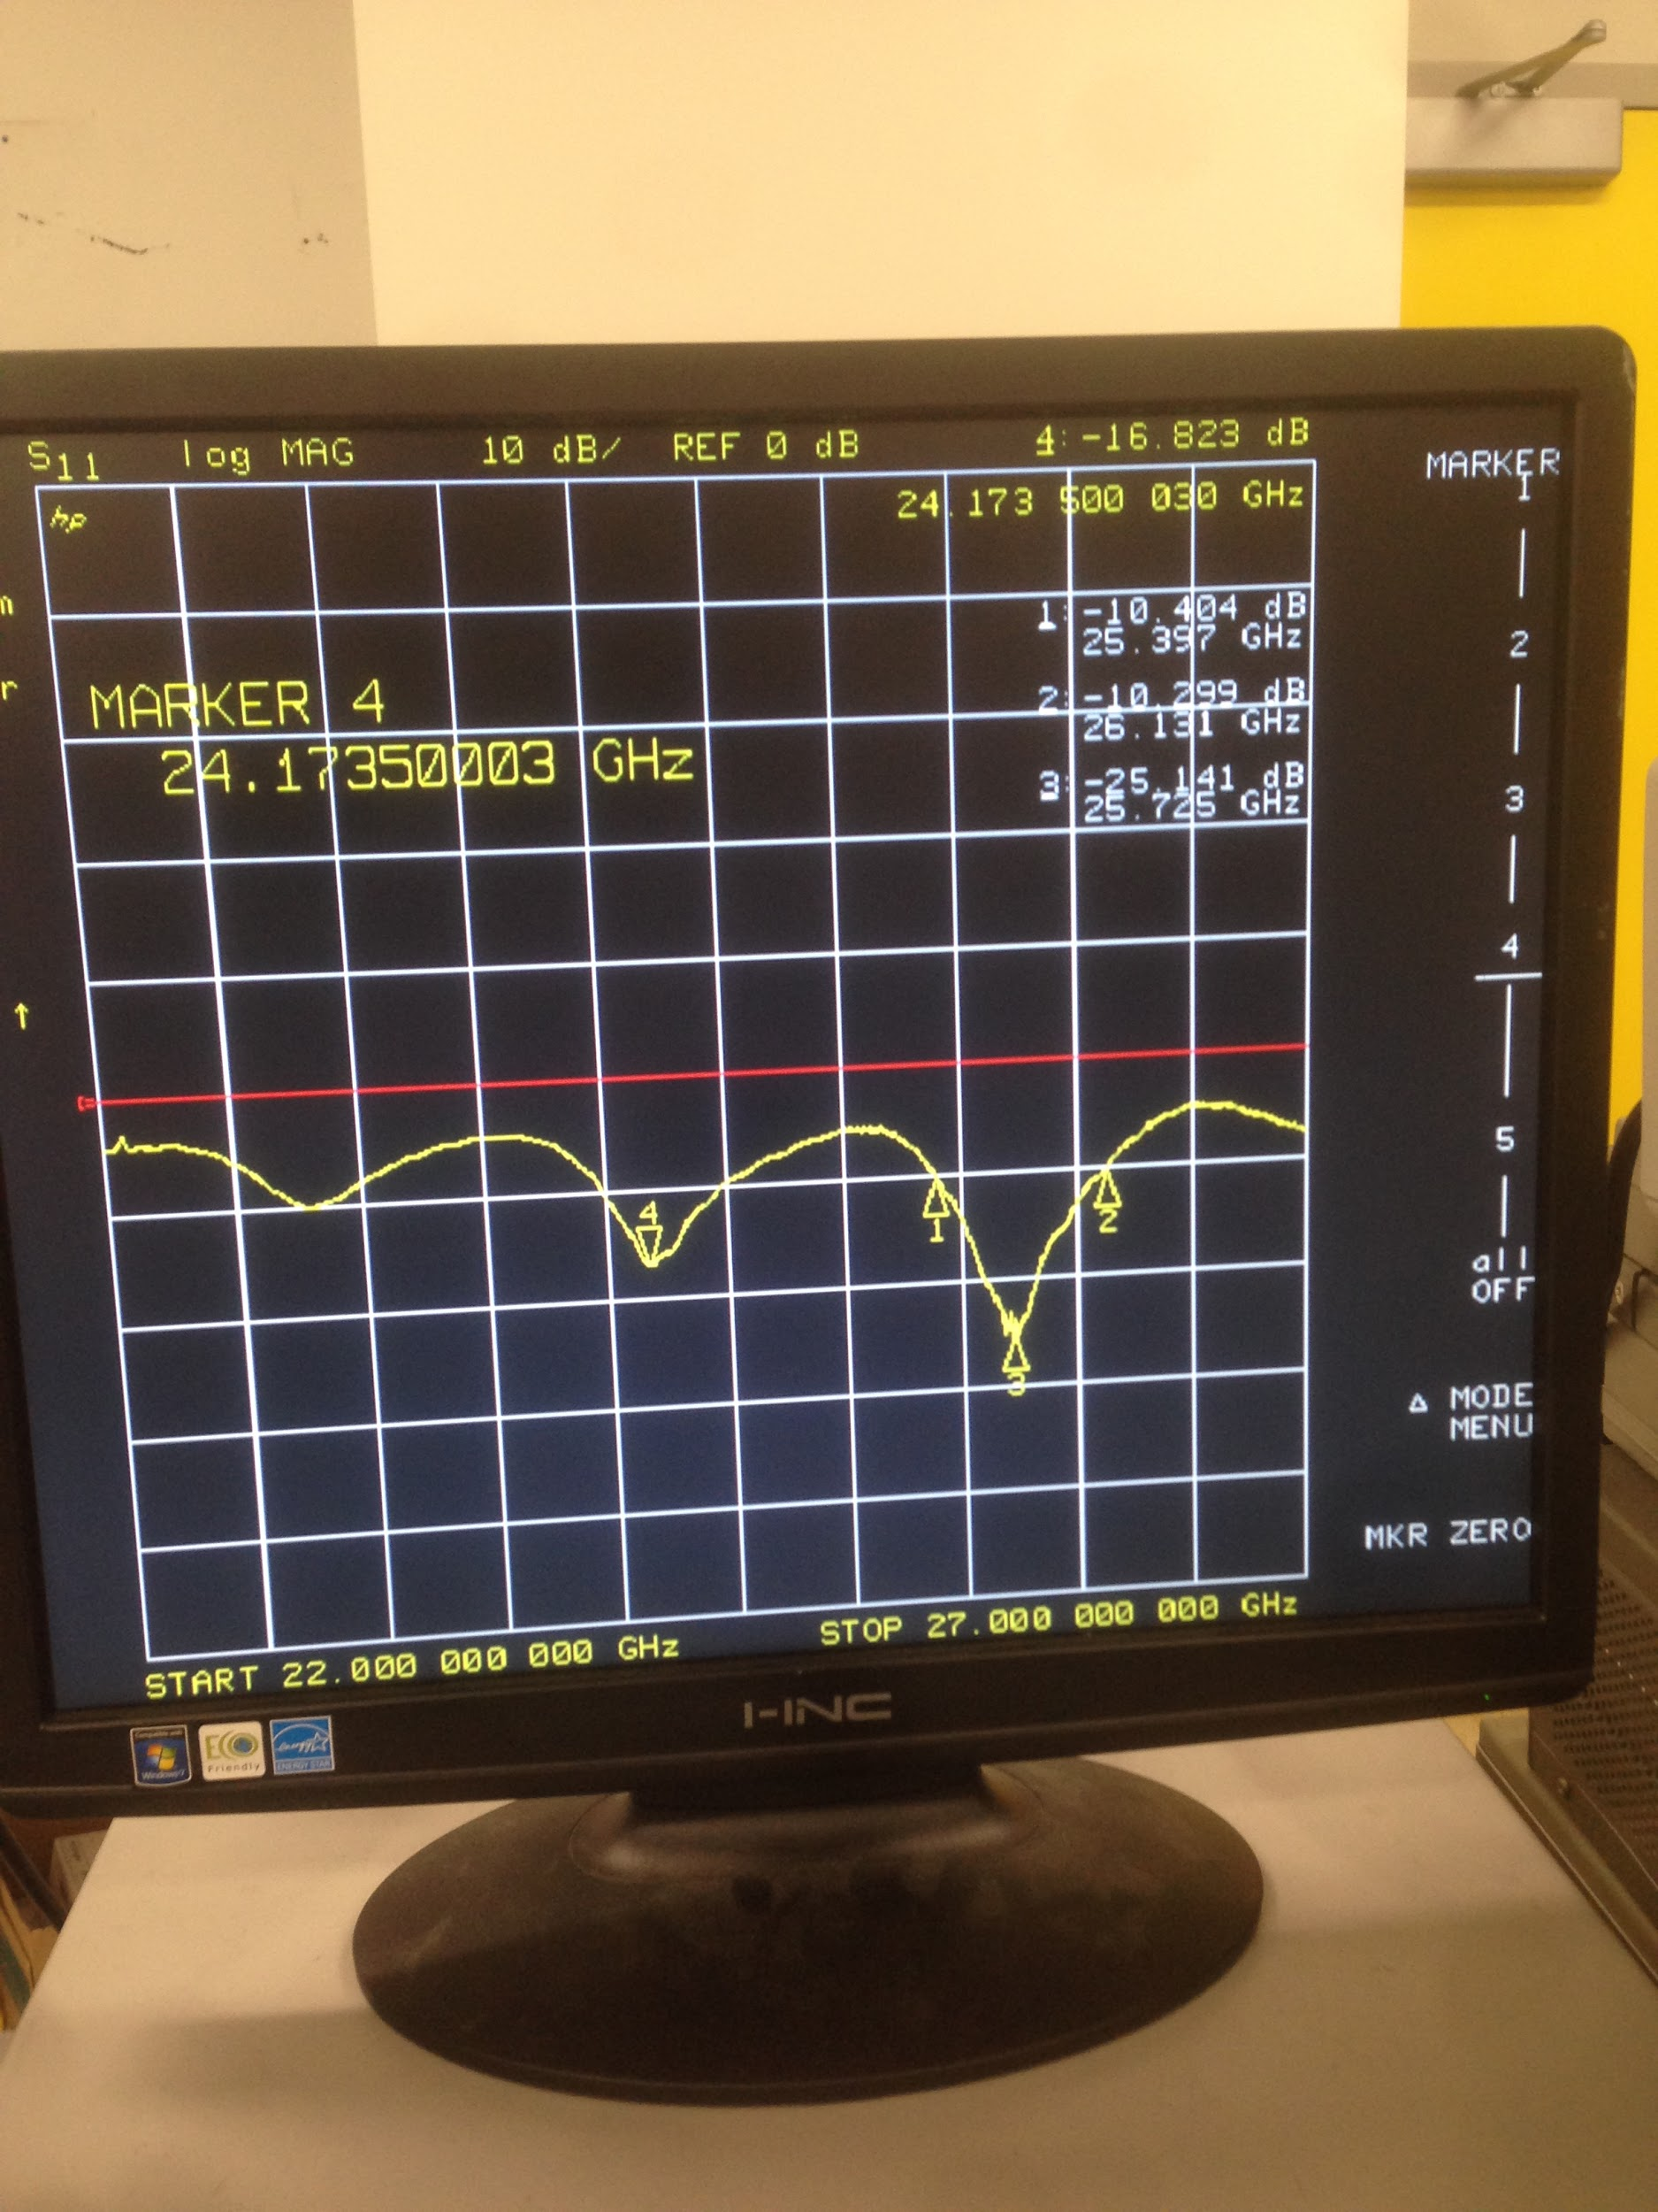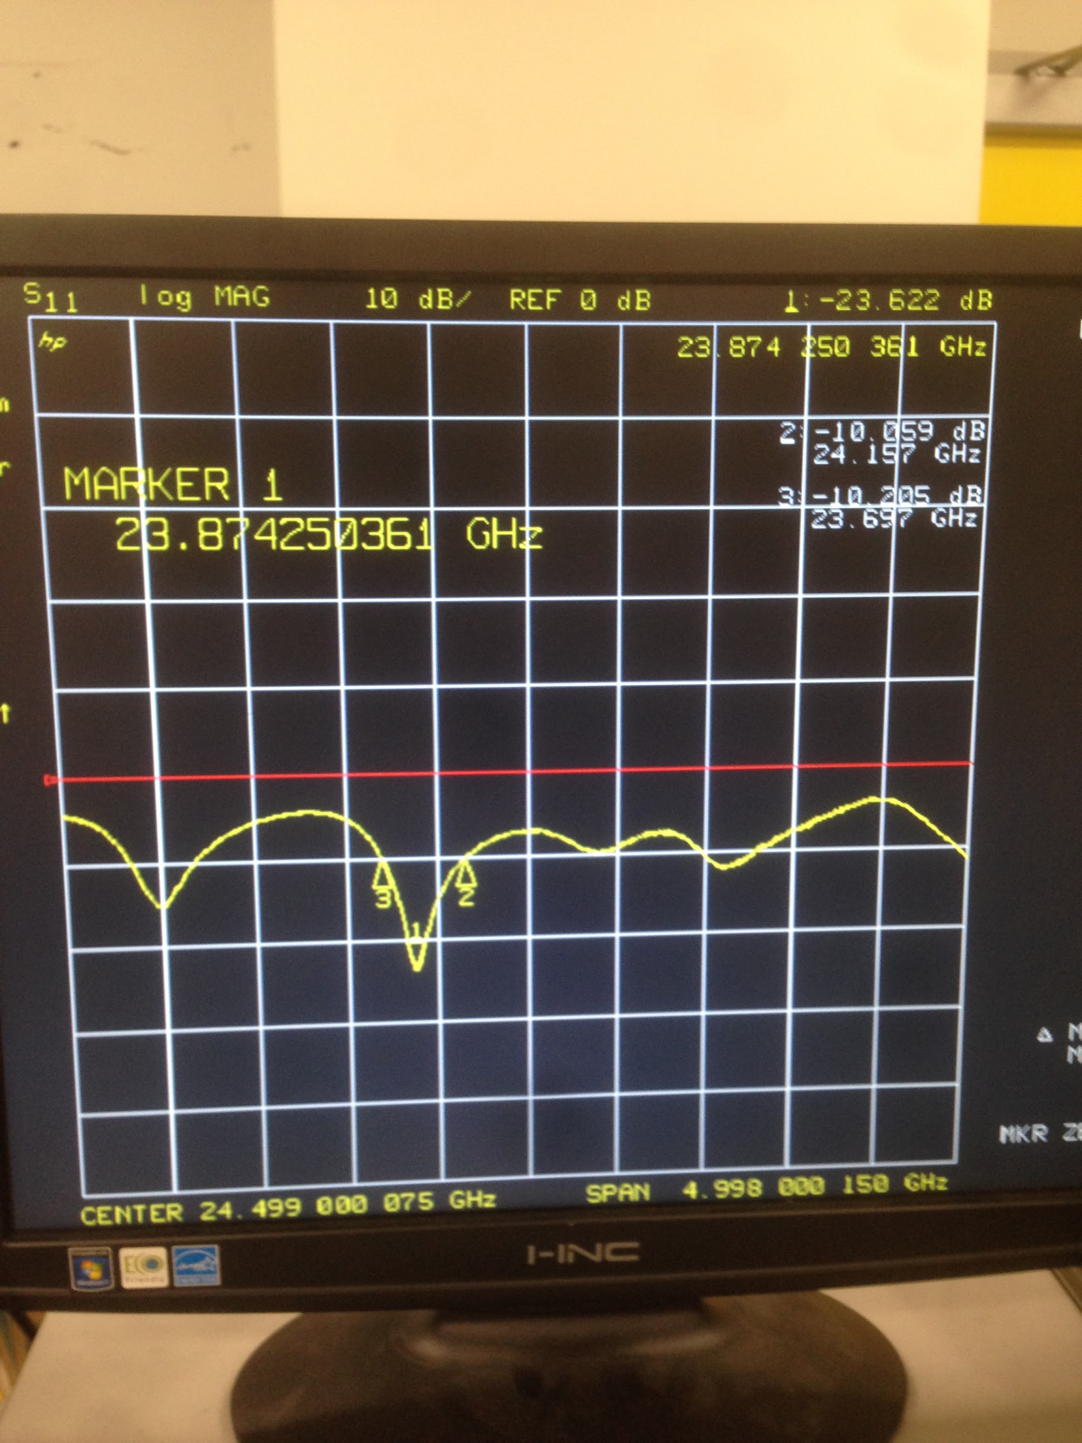

**Meijao 25GHz Hao 26GHz**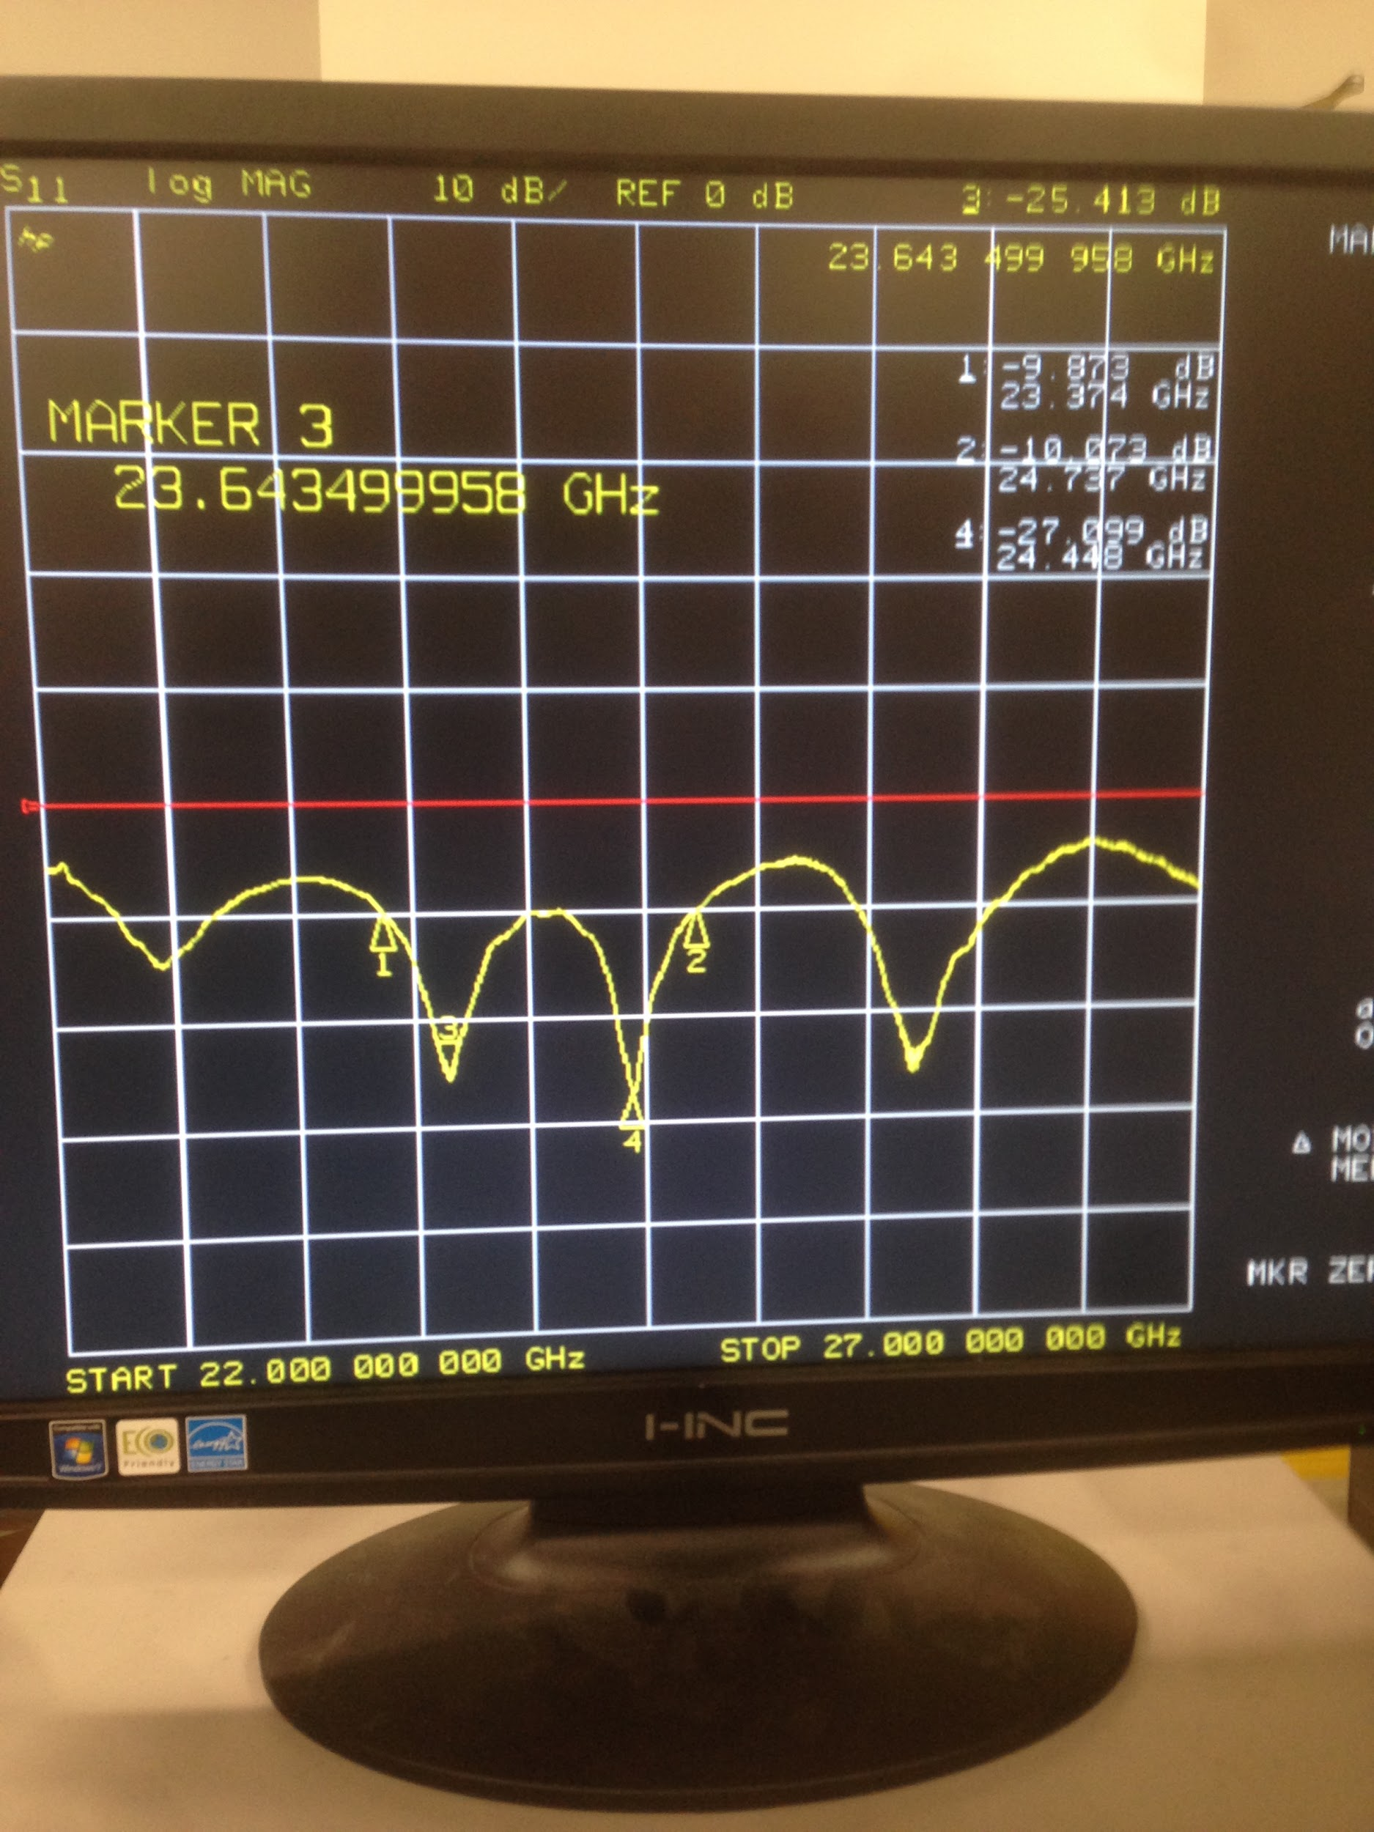

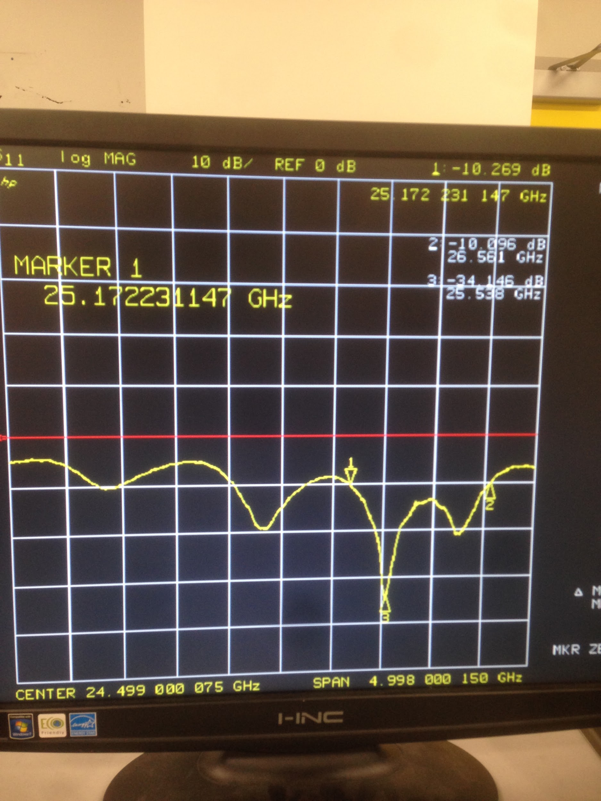

**Performance of RF Board**

Because of the problem with stacking the entire system (TIVA, baseband and RF board) we often used wires to connect all of the essential ports of the RF board to the rest of the system. We were also unable to get the digital DAC to remain running when all three layers were attached via the 10x10 headers. We were able to initialize the Power Amplifier of the Infineon via SPI and not have to keep initializing it. This cut down noise considerably.

The first mode of operation we tested was the doppler mode. We did not have any equipment to test the system, so we simply used a metal chair as a target inside the lab and moved it by hand back and forth. We hooked the I and Q ports of the demodulated signal directly from the Infineon to an Oscilloscope. The demodulated signal was surprisingly strong directly out of the Infineon. The strongest amplitude of the demodulated signal was around 30 mV. We next moved back farther and farther in order to get a rough idea of the directivity of the antennas set at their lowest position of return loss. We were able to get a returned signal of around 10-20 mV from a distance of about 7-8m without a baseband amplifier for the demodulated signal. The antennas and the impedance matching networks were a success! The results of the actual matlab processed measurements are listed in the tests and results section.

We then decided to hook up a function generator in the lab in order to get an idea of how the FMCW mode would work. We set the course tune and ramped the fine tune pin of the Infineon at a triangle wave frequency of around 2 kHz. A strange return signal was observed, which could be the results of reflections inside our system, or reflections from the walls. After thinking about the possibilities of the problem, it was determined that the reflection of RF waves in the room was most likely the cause.

**Baseband**

The baseband circuit has many functions: power regulation, fine tune (triangle wave) control, and analog signal processing of the infineon’s output signal. A power header allows the entire system to be powered from one source, which feeds a 5 volt, 3.3 volt, and coarse tune voltage regulators. A DAC, controlled by the Tiva, is used for fine tune of the infineon, and a mode switch is used to change from FMCW to doppler mode.

The most important function of the baseband is to lowpass the Infineon’s output, and bring it to a 1.5 volt biased, 3Vpp swing for the ADC of the Tiva or computer. The output of the infineon is fed through the 2X10 header directly to the automatic gain control amplifier, which brings the signal to 1Vpp. The signal is then sent through a four-pole low pass filter, which passes only the low frequency signal (less than 20kHz), and cuts any noise from the infineon or SPI traces.

Ultimately, we designed a second version of the baseband circuit. This was because the first version had these issues:

1. The DAC footprint was incorrect and much too large

2. The voltage regulartors’ thermal pads were too small

3. The mode switch was connected to 5 volts instead of 3.3 volts

4. The power pin hole size was too small for the intended header

5. The 2X10 headers were 10 mils too high

6. The AGC amp didn’t work well below 1k there was some clipping

7. The LPF cutoff frequency was about 60kHz, when it should be 20-30kHz

**Baseband V1**

The schematics and PCB layout for baseband circuit V1 are depicted below:

*Automatic gain control amplifier and lowpass filter schematic*

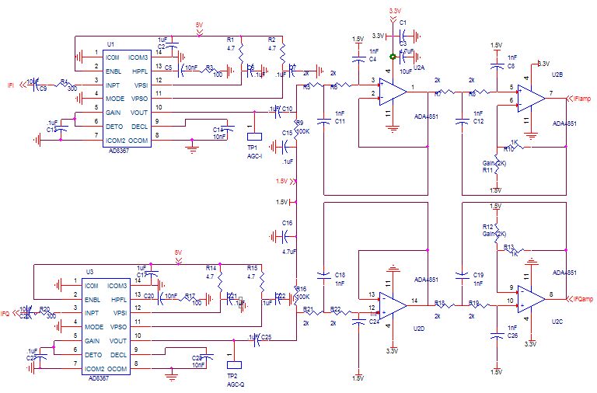

*Voltage regulators and header pins*

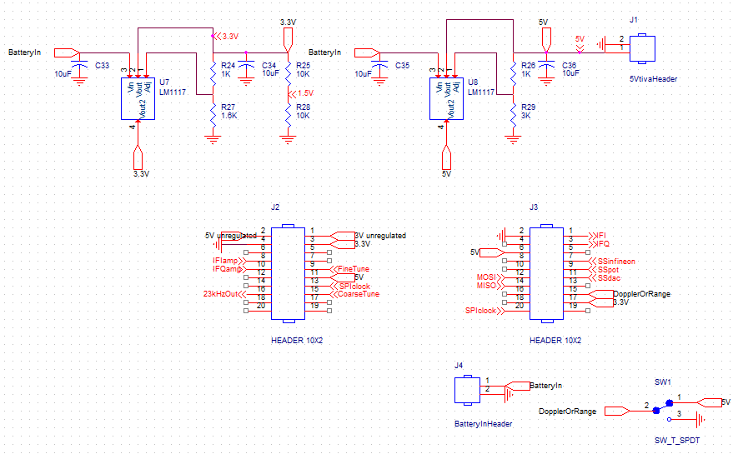

*Coarse-tune and fine-tune voltage regulator and DAC for RF control*

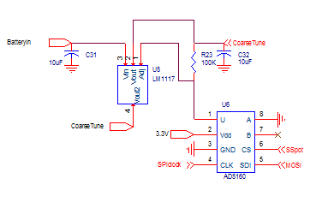

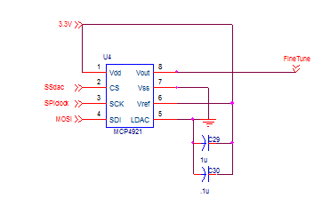

*Baseband V1 PCB Layout*

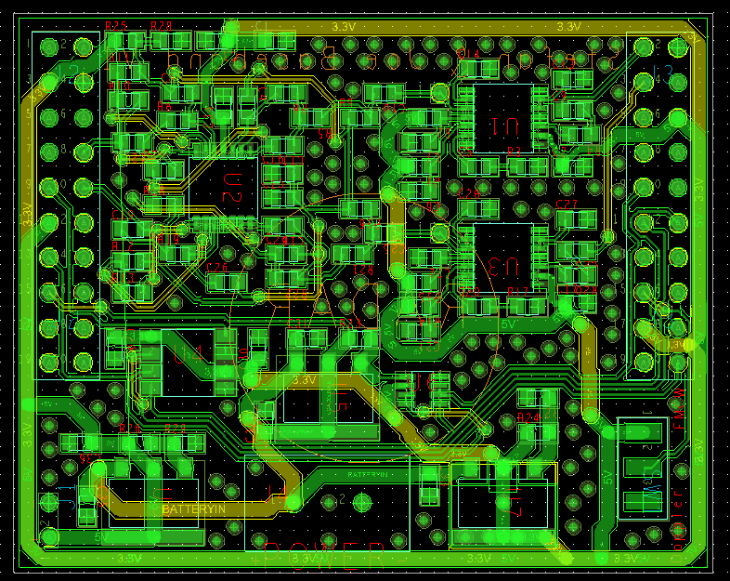

**Baseband V2**

On the second version of the baseband circuit, the only schematic change was the AGC amplifier. All other changes were on the PCB layout:

*Altered AGC*

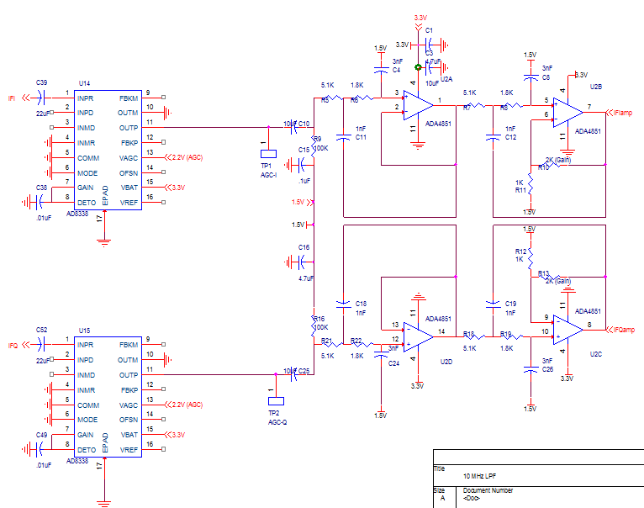

*Baseband V2 PCB*

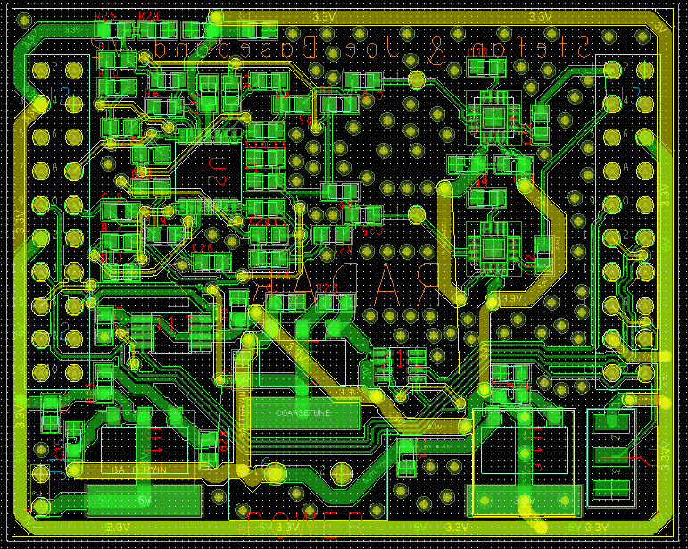

**Issues**

After assembling the PCB’s described above, we encountered several issues with the system. We found ways to solve some of the problems, but others are still left a mystery. All groups that want to pursue a similar design to our group in coming years should be notified of these possible problems, especially if other groups suffered from the same problems. Each problem is described in detail below:

* **SPI reflection:** This was the most problematic of all the issues. Even though we felt that we designed the SPI traces correctly (its fairly simple), we could not control multiple devices with SPI. We could easily control the triangle wave, and we could easily turn on the PA of the BGT24. But if we put both boards together, and tried to first turn on the PA, and then start the triangle wave, the triangle wave would not work, seemingly because of SPI reflections or signal mixing. If we used wires to connect certain boards, instead of the 2X10 headers, it would work much better.

**Possible Causes:**

* + An extremely small short between the CLK and MOSI traces near the Infineon
  + Voltages higher than 3-5 volts on tiva pins may cause Tiva to enter some kind of safe mode that turns off SPI
* **80KHz output instead of 23KHz:** The Q2 output of the Infineon BGT24 is useful because it is supposed to divide the LO signal by approximately 1 million: to 23 KHz. Unfortunately, we always got a Q2 output (square wave) that was above 80KHz.

**Possible Causes:**

* + Reflections from the terminating resistors of Q1, at 1.5 GHz. We neglected to use high frequency resistors, but they should have been fine at 1.5-24 GHz anyway. When we removed the Q1 terminating resistors, the output came down to 50 KHz.
* **AGC Amplifiers:** Both variable gain amplifiers (placed in AGC mode) that we employed in [Baseband V1](http://www.digikey.com/product-detail/en/AD8367ARUZ-RL7/AD8367ARUZ-RL7CT-ND/3897175) and [Baseband V2](http://www.digikey.com/product-detail/en/AD8338ACPZ-R7/AD8338ACPZ-R7CT-ND/4171715) had issues.
  + **AD8367:** The first chip worked as expected, but only at high frequencies. These chips are designed to be used in digital communications circuits, which operate in the low MHz. As a result, we could not get a clean signal under a few KHz. This would work decently well for FMCW, when the output of the infineon is in the KHz range. But in doppler mode, the output signal is closer to 10 Hz. This signal would be destroyed by the AD8367. We decided this was too large of a problem, so we designed a new baseband circuit with the AD8338 IC.
  + **AD8338:** This style of chip was much harder to solder to the board because the pins are only exposed under the board. When you solder the chip, you are not certain that all pins are connected, and that there are not shorts. *Please advise all students to avoid this chip style if possible!*
  + **Possible remedy:** Use a standard amplifier and LPF, with a digital potentiometer instead of the gain resistor. The gain can then be controlled by a relatively simple algorithm that ensures that the output of the LPF is between 1-3 volts.
* **Digital Potentiometer:** We could never get the digital potentiometers to change their resistance value, even though we had working SPI code.
  + We probably soldered the potentiometer incorrectly, because the resistance from the wiper to one of the ends was way too large. When we tried to resolder the chip, we lost it. It’s very small!!
* **Coarse Tune Current Draw:** when the coarse tune was set above 5 or 6 volts (it shouldn’t be this high), the power supply would sometimes short, and the Tiva would turn off. This implies that the Tiva cannot handle voltages on the pins above 3-5 volts.

**Temporary remedy:**

* + We simply bent down the pin that created the problem. This worked well, but obviously destroyed the Tiva to a degree. *Please tell future students that it is a possibility to momentarily incapacitate the Tiva if a high voltage is applied to the pins.*

**Tests and Results**

The Matlab plot of our Doppler return signal is shown below. One can see that the vehicle is accelerating from 0 to 6 seconds and decelerating from 12 to 16 seconds. The line in the middle is likely another car on the street. All speed measurements are reasonably accurate: Joe drove at a maximum of 13 mph.

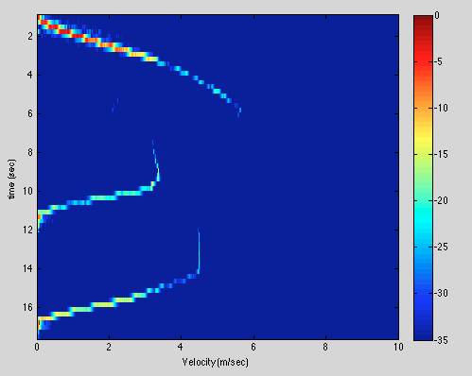

The frequency response of our low pass filter is plotted below:

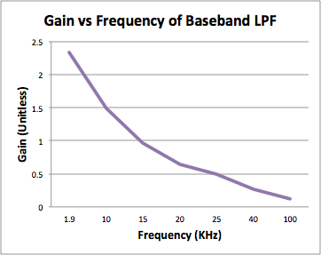

The triangle wave that we produced from out Tiva and DAC is shown below. The fastest we could run the triangle wave without intense distortion was approximately 1-4 KHz, but a cleaner, 80 Hz wave is shown below:

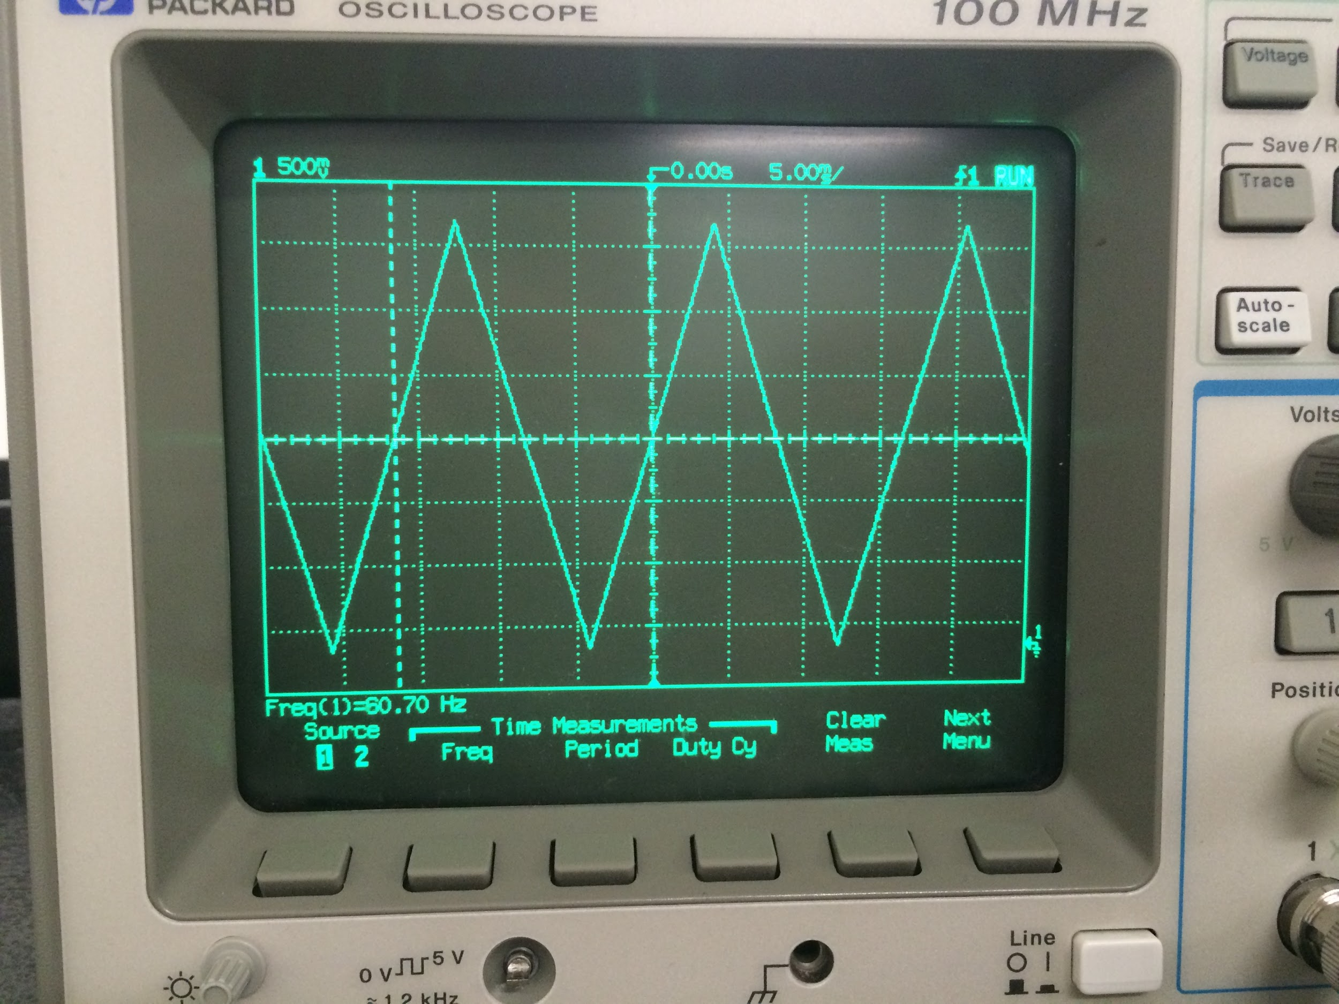

The Q2 output of the infineon would almost always be oscillating at the incorrect frequency of 82.14 KHz, as shown below:

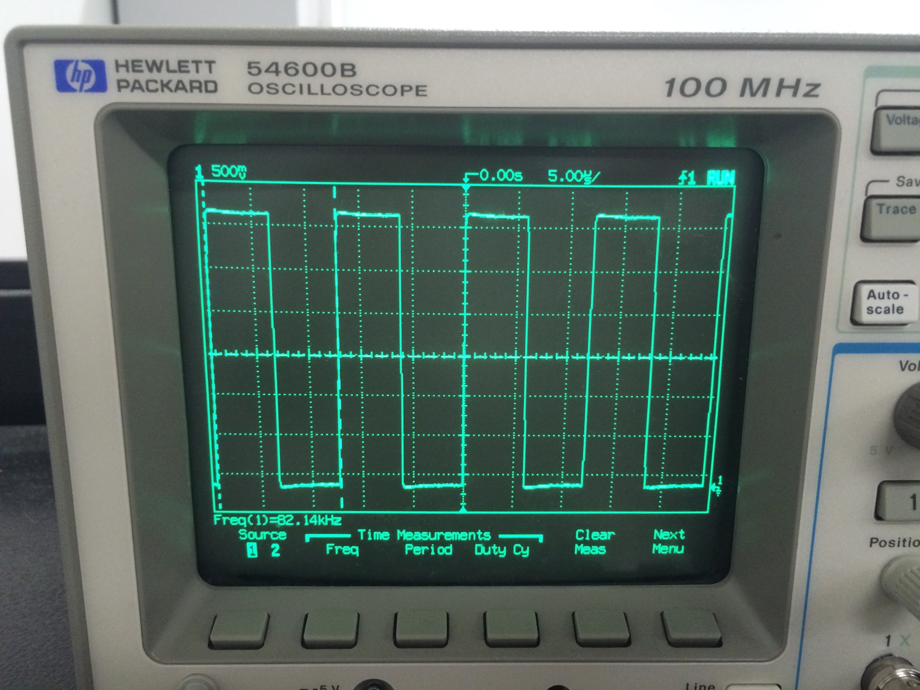

However, the first time we populated an RF board with an Infineon, but without terminating resistors, the Q2 output was at 24.72 KHz: approximately how it should be.

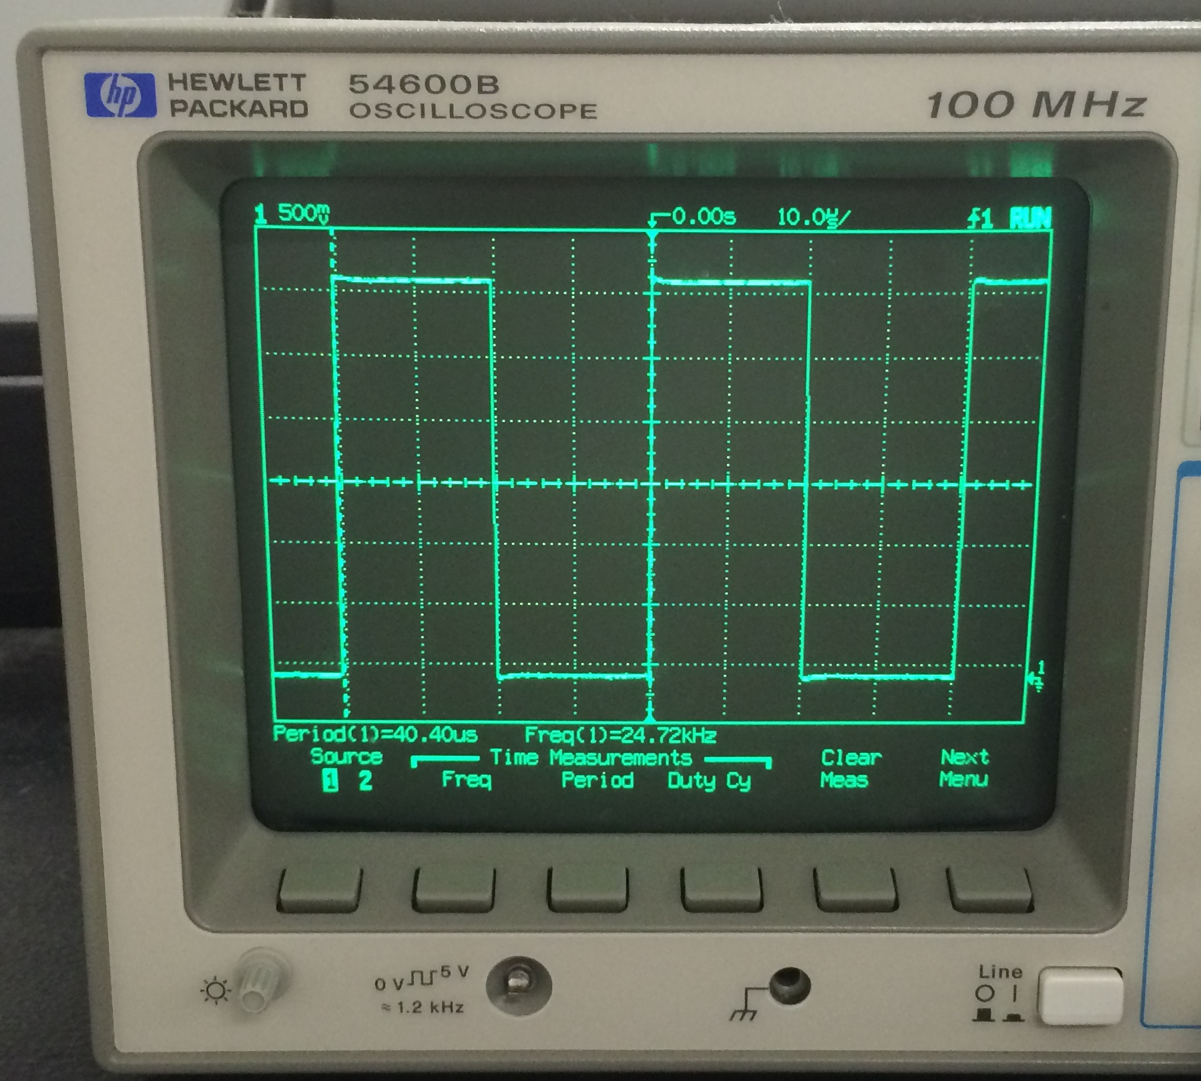

The first automatic gain control amplifier worked relatively well at higher frequencies, it only slightly clipped the signal, but did not amplify the signal to 1 Vpp like the datasheet boasted. On the oscilloscope below, you can see the input (top) and output (bottom) signals of the AGC amplifier:

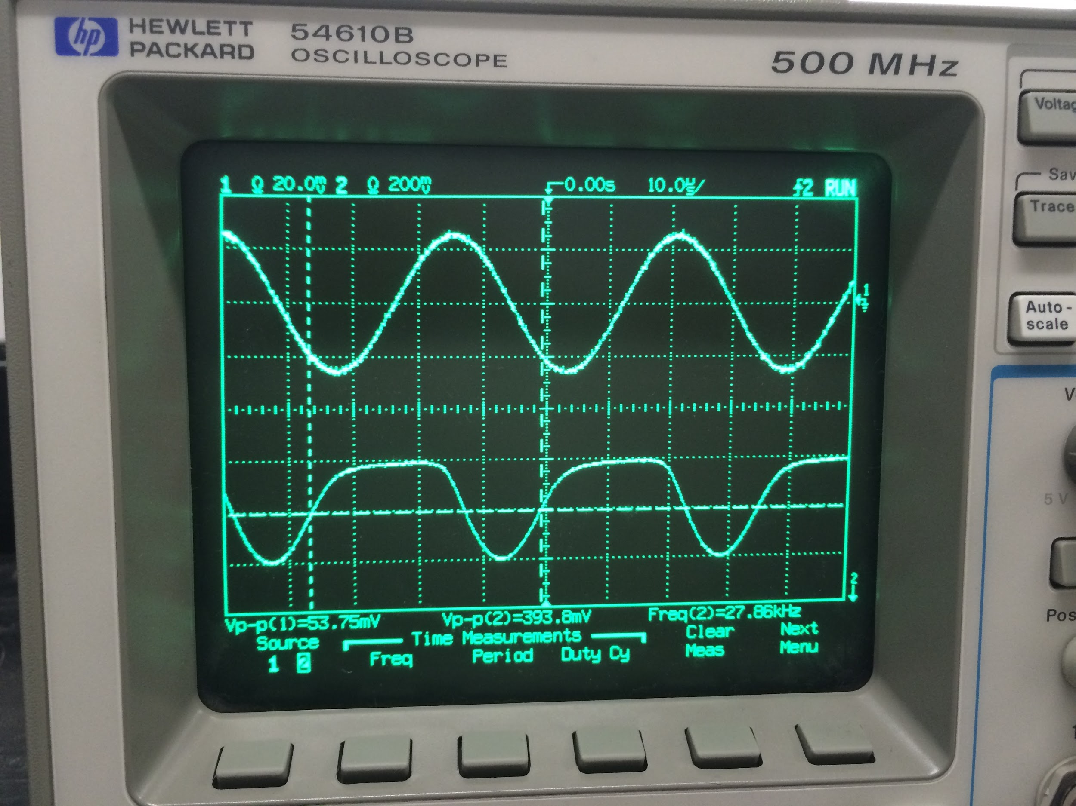

However, when using frequencies under approximately 1 KHz, the AGC amplifier would distort the signal even more as well as introduce very high frequency abnormalities. This rendered the AGC amplifier useless for doppler measurements. On the oscilloscope below, you can see the input (bottom) and output (top) signals of the AGC amplifier:

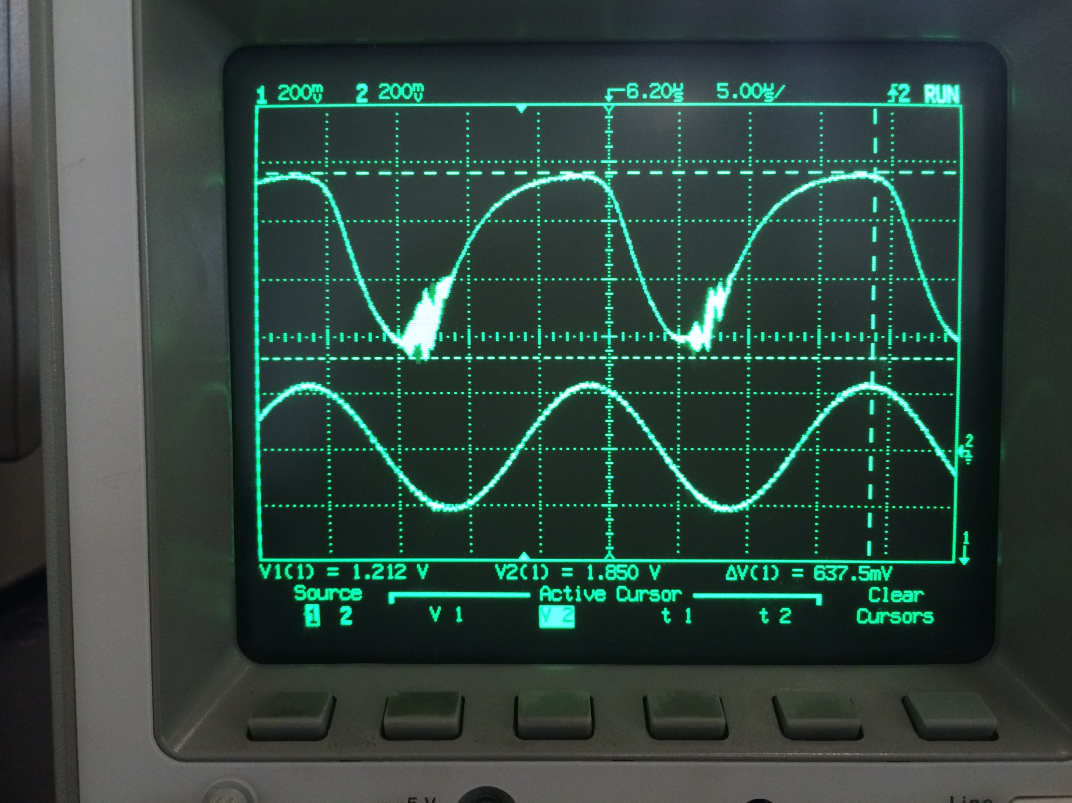

**Possible Improvements**

* Simple function generator chip instead of using digital function generator from microcontroller. This would also help with noise considerations. SPI generates excessive noise.
* Setting unused I/O pins on TIVA to high impedance (possibly solution for shorting problems)
* Rogers RO4350B 2oz copper instead of 1oz.

**Conclusion**

We were able to get the system operating in Doppler mode by initializing the Infineon’s Power Amplifier. Much of the time testing the RF board required us to directly wire the SPI ports from the TIVA to the RF board due to the bugs associated with stacking the three layers. In the end, our system works as a stacked system with one battery.

The final weight of our system was 54 grams. The power consumption was approximately 1 watt. The accuracy of the system is reasonably accurate.

Our team designed both the Infineon breakout board and the Baseband board for signal processing the demodulated signal. These two boards worked very well together, but when put together with the Texas Instruments TIVA, many bugs appeared in our system. It was a difficult task to debug and track down all of the problems that developed when we stacked all three layers, but we found a majority of the bugs and temporary solutions were implemented in order to get the first version of the system running. The experience gained from designing a system from the ground up is irreplaceable and will benefit our team for many years to come!

**Course Suggestions**

* Show students the applications notes in quarter 1. Force them to read a few.
* Familiarize students with microcontroller architecture. Recommend that they take a few classes (EEC172) based in this field of Electrical Engineering.
* Offer on campus tutorials for learning Cadence Allegro.
* Push students through the first quarter labs (1 week each is definitely possible) and start the design process in first quarter. Encourage them to have a design and components by winter break. The second quarter should be mostly about building, testing, and rebuilding.
* Inform students of possibly using an analog function generator to reduce system noise level. (Jameco XR-2206).
* Throughout the entire process of designing the PCB’s, there were licensing issues with UC Davis license key server. We had to seek technical support multiple times in order to resolve this issue. Once we finished the design and ordered the PCB’s we did not access Cadence for multiple months. During the third quarter of our design, we tried to access Cadence to make additional changes, but could not get the program to run due once again to license errors.